Assembly and
Operation of the


Universal Radio Module
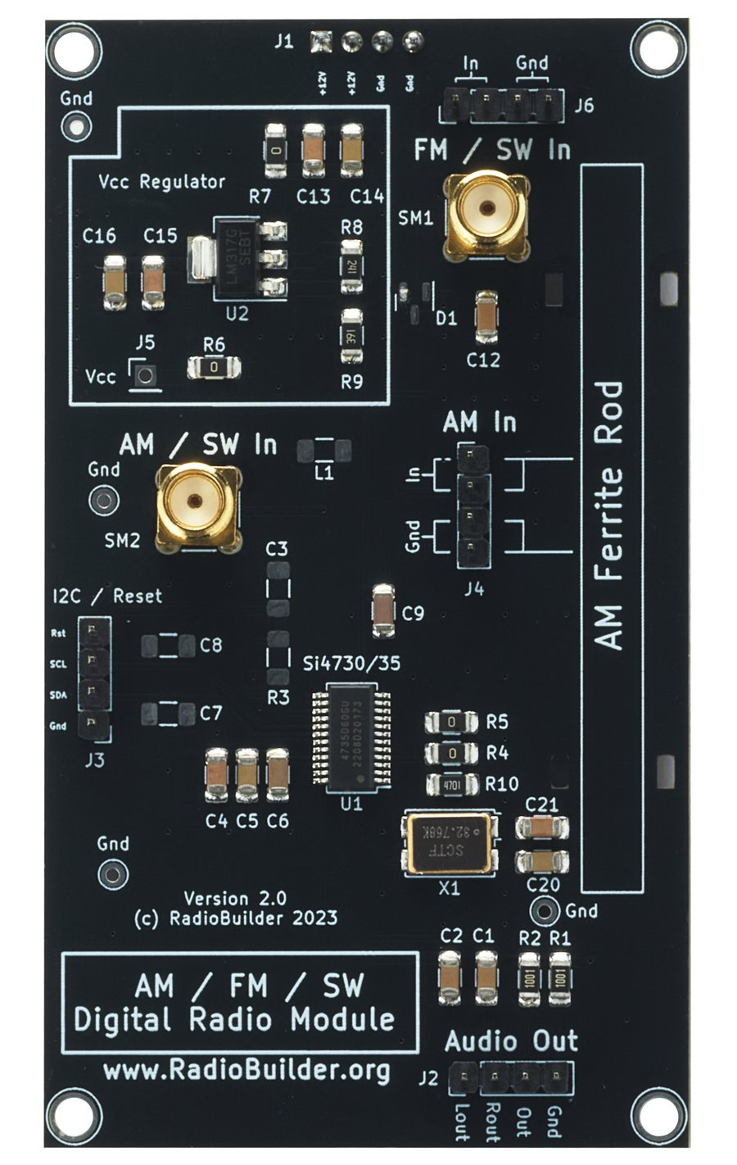
Component of the RadioLab
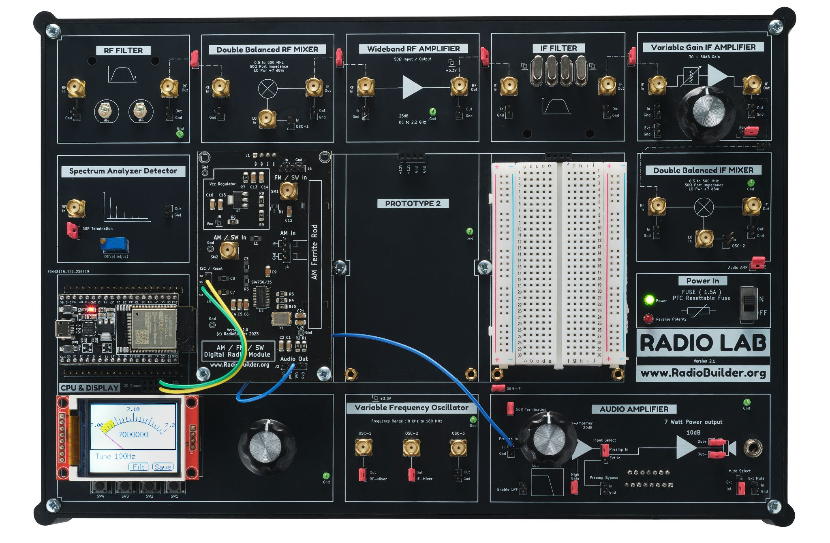

Contents
1.0 Universal Radio Overview 3
1.1 Universal Radio Module Specifications 3
2.0 Universal Radio Theory 4
2.1 Theory of Operation 4
2.2 Connection Diagram 5
2.3 Antennas 5
2.4 Operation 6
2.5 Band Plan Used by the SSB Sketch 6
3.0 Schematic Diagram 8
4.0 Circuit Description 9
4.1 Power Supply (U2) 9
4.2 Reference Clock (X1) 9
4.3 Control Interface (J3) 9
4.4 FM / SW Input (SM1, J6) 9
4.5 AM / SW Input (SM2, J4) 10
4.6 Audio Output (J2) 10
4.7 Decoupling 10
5.0 Embedded Software 11
6.0 Signal Tracking 13
6.1 DC Test Point Voltages 13
6.2 Audio and Signal Quality 13
7.0 Experiments 14
7.1 Antenna Comparison 14
7.2 SSB Bandwidth 14
7.3 CW Reception 14
7.4 2M FM Using an External Mixer 14
8.0 Assembly 15
8.1 Complete Assembly 15

1.0 Universal Radio Overview
The Universal Radio Module is a complete AM, FM, shortwave (SW) and longwave (LW) receiver built around a single chip, the Si4735-D60. Where the FM Broadcast Receiver Module builds a superheterodyne radio from separate RF filter, mixer, IF filter and demodulator blocks, the Si4735 does all of this inside one IC. The tuning, filtering and demodulation are done in software (digital signal processing, DSP) and there are no coils to wind or trimmers to adjust.
The ESP32 on the CPU & Display board controls the chip over I²C. With a firmware patch loaded at start-up, the Si4735 also receives SSB (LSB/USB) and CW, so the module can be used to listen to the amateur HF bands as well as broadcast stations.

1.1 Universal Radio Module Specifications
Parameter | Typical Value
Receiver IC | Si4735-D60-GU (SSOP-24)
FM band | 64 – 108 MHz (sketches use 84 – 108 MHz)
AM (medium wave) band | 520 – 1710 kHz
SW band | 2.3 – 26.1 MHz
LW band | 153 – 279 kHz
Modes | FM (stereo/mono), AM, SSB (LSB/USB), CW
FM sensitivity | 2.2 µV EMF (26 dB S+N/N)
AM / SW sensitivity | 25 µV EMF (26 dB S+N/N)
FM adjacent channel selectivity | 50 dB at ±200 kHz
AM channel filters | 1, 1.8, 2, 2.5, 3, 4, 6 kHz
SSB audio bandwidths | 0.5, 1.0, 1.2, 2.2, 3.0, 4.0 kHz
FM input (FMI) | ≈ 4 kΩ in parallel with 5 pF
Audio output (line level) | 80 mV RMS FM, 60 mV RMS AM
Reference clock | 32.768 kHz oscillator (X1)
Control interface | I²C (2-wire), address 0x11
Supply | +12 V on J1, 3.3 V on-board regulator
Supply current (estimate) | 25 mA (22 – 30 mA)

2.0 Universal Radio Theory
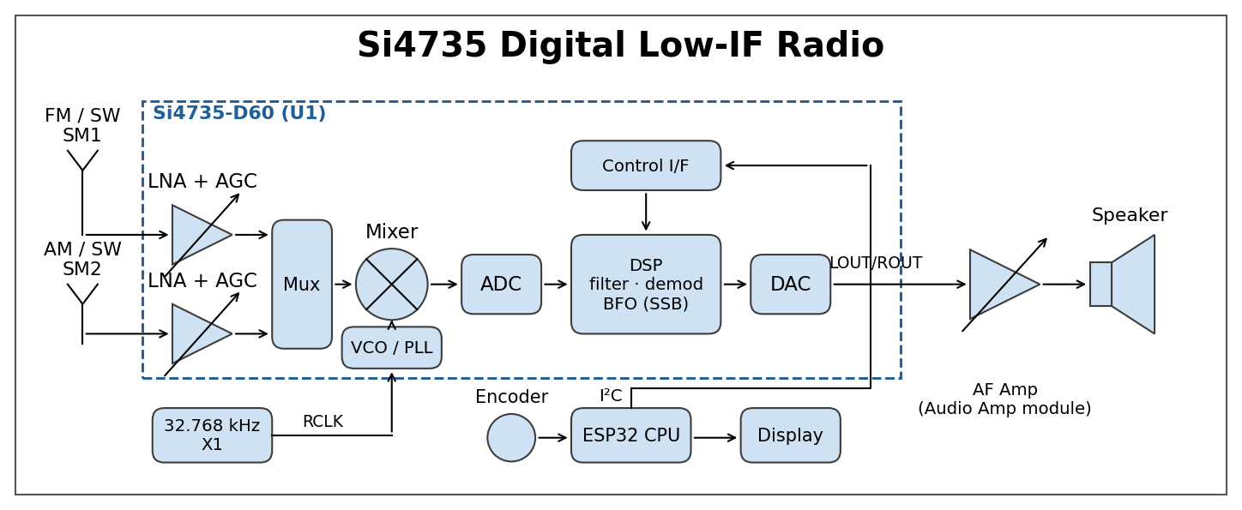
Block Diagram

2.1 Theory of Operation
The Si4735 uses a digital low-IF architecture. There are two antenna inputs: FMI for FM and AMI for AM, LW and SW. Each input has a low-noise amplifier (LNA) with automatic gain control (AGC). The AGC turns the gain down on strong signals so the stages that follow are not overloaded.
The amplified signal is mixed with an on-chip local oscillator (VCO/PLL) and converted to a low intermediate frequency. The PLL is locked to the 32.768 kHz reference from X1, so every frequency the chip tunes is set by that one reference.
The IF signal is converted to digital by an analogue-to-digital converter (ADC). From here on the radio is software running in the chip's DSP. The DSP applies the channel filter, demodulates FM or AM, decodes FM stereo, and applies soft mute and de-emphasis. A digital-to-analogue converter (DAC) then produces left and right audio at the LOUT and ROUT pins.
For SSB and CW, the ESP32 loads a firmware patch into the chip's RAM at start-up. The patch adds a beat frequency oscillator (BFO) and SSB filters to the DSP. The patch is lost at power-off and reloaded each time the sketch starts.
The ESP32 on the CPU & Display board sends commands to the chip over I²C: tune, set band, set bandwidth, set volume. It also reads back RSSI (signal strength) and SNR (signal-to-noise ratio). The recovered audio is line level and is routed to the Audio Amplifier module.

2.2 Connection Diagram
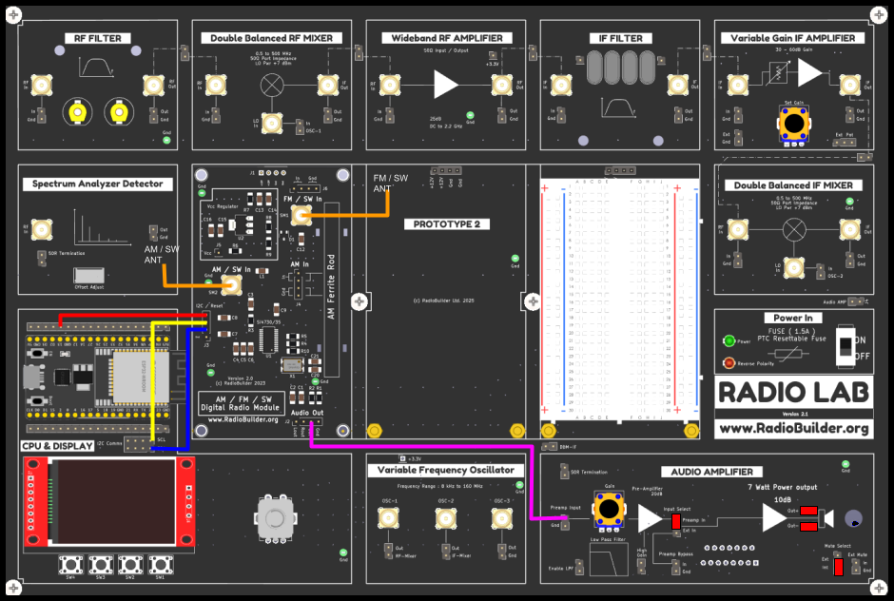
Connection Diagram
- I²C / Reset (J3) – Control Signals
- Audio Out (J2) – Out (or Lout) to the Preamp Input of the Audio Amplifier.
- FM / SW In (SM1) – FM antenna.
- AM / SW In (SM2) – SW wire antenna, or the AM ferrite rod on J4.

Control Interface Connections (J3)
J3 Pin | Signal | ESP32 Pin | Connect To
2 | SDA | SDIO (18) | SDA on I2C Comms header
3 | SCL | SCLK (17) | SCL on I2C Comms header
4 | Rst | RST (15) | ESP32 GPIO13
Gnd (J3 pin 1) is not required. Ground is connected through the supply header J1.

2.3 Antennas
FM – For strong local stations a wire of approx 75 cm (a quarter wave at 100 MHz) on SM1 or J6 will work. For weaker stations use the FM dipole described in the FM Broadcast Receiver Module manual.
AM (medium wave / longwave) – Fit the AM ferrite rod to J4. The Si4735 tunes the ferrite rod automatically with an internal capacitor, so there is no tuning capacitor to adjust. The rod is directional: rotate the board for the best signal.
SW / amateur HF – Connect a wire antenna of 5 – 20 m to SM2, as high and as far from mains wiring as possible. An outdoor wire gives a large improvement over an indoor wire. Disconnect outdoor antennas during thunderstorms.
The FM input is high impedance (≈ 4 kΩ), not 50 Ω. A short length of 50 Ω coax to the antenna is fine, but the input is not matched to it.

2.4 Operation
FM broadcast
- Download the Si4730_FM_Radio_FULL sketch to the board.
- Connect the FM antenna to SM1.
- Turn the encoder to tune. Each click moves 100 kHz.
- Press SW1 – SW4 briefly to recall presets P1 – P4.
- Hold a preset button for approx 5 s to store the current station. The preset box flashes red.
- On first use, store a station in each of the four presets.

SSB / CW on the amateur bands
- Download the SI4735_SSB_CW_Prototype sketch to the board.
- Connect a wire antenna to SM2.
- Open the Serial Monitor at 115200 baud and check that the SSB patch loads.
- Press SW3 to step through the bands. The sketch starts on 40 m (7.146 MHz LSB).
- Turn the encoder to tune. Press SW2 to change the step between 100 Hz and 1 kHz.
- Press SW1 to change the audio bandwidth. Use 2.2 – 3.0 kHz for SSB and 0.5 – 1.0 kHz for CW.
- Press SW4 to print AGC, bandwidth, SNR, RSSI and volume to the Serial Monitor.

2.5 Band Plan Used by the SSB Sketch
Band | Range in Sketch | Start Frequency | Sideband
MW | 520 – 2000 kHz | 810 kHz | LSB
80 m | 3500 – 4000 kHz | 3510 kHz | LSB
60 m | 5258 – 5406 kHz | 5400 kHz | USB
40 m | 7000 – 7200 kHz | 7146 kHz | LSB
25 m (broadcast) | 11700 – 12000 kHz | 11940 kHz | USB
20 m | 14000 – 14300 kHz | 14200 kHz | USB
17 m | 18000 – 18300 kHz | 18100 kHz | USB
15 m | 21000 – 21400 kHz | 21200 kHz | USB
12 m | 24890 – 25000 kHz | 24940 kHz | USB
11 m (CB) | 27000 – 27700 kHz | 27300 kHz | USB
10 m | 28000 – 28500 kHz | 28400 kHz | USB

The 11 m and 10 m bands are above the Si4735 datasheet limit of 26.1 MHz. Reception above that limit is not guaranteed.

3.0 Schematic Diagram
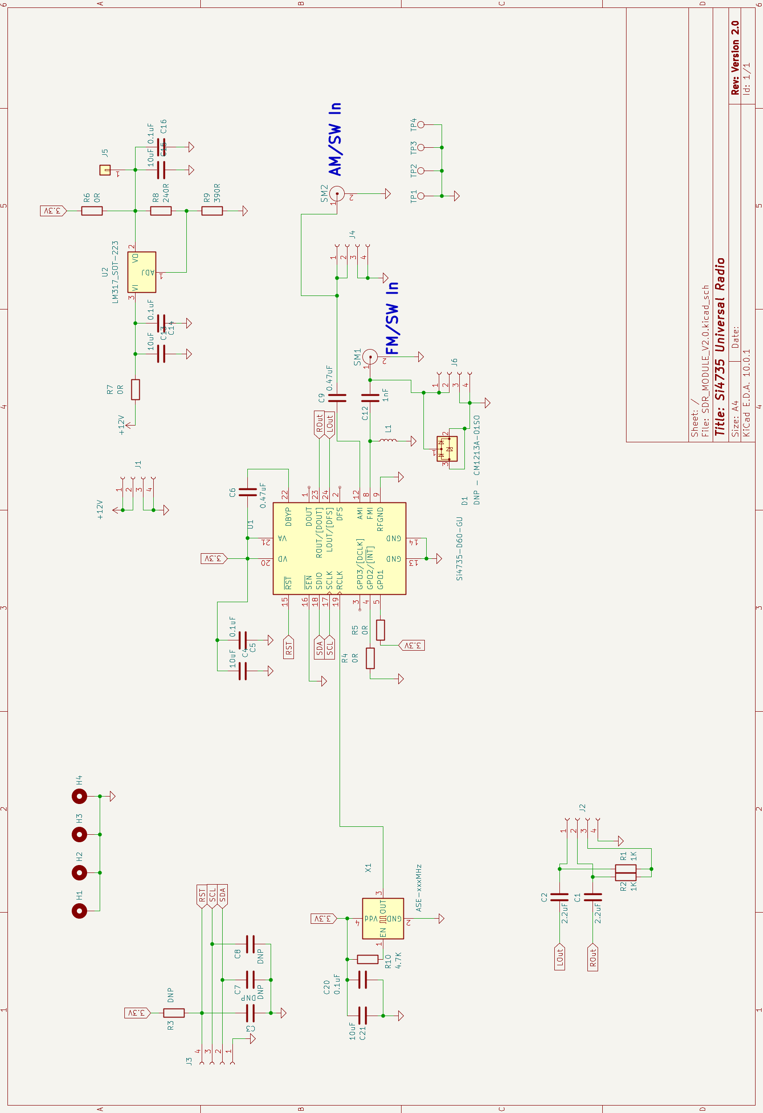
Universal Radio Module Schematic

4.0 Circuit Description

4.1 Power Supply (U2)
The module takes +12 V from J1 (pins 1 and 2 are +12 V, pins 3 and 4 are Gnd). An LM317 adjustable regulator (U2) produces the 3.3 V supply for the radio IC and reference oscillator. The output voltage is set by R8 and R9:
Vout = 1.25 V × (1 + R9 / R8)
Vout = 1.25 V × (1 + 390 / 240) = 3.28 V
R8 also provides the minimum load the LM317 needs to regulate: 1.25 V / 240 Ω = 5.2 mA.
Power dissipated in U2 is (12 V − 3.28 V) × 25 mA ≈ 0.22 W. The SOT-223 package handles this without a heatsink.
- C13, C14 (10 µF, 0.1 µF) – input decoupling.
- C15, C16 (10 µF, 0.1 µF) – output decoupling.
- R7 (0 Ω) – input link.
- R6 (0 Ω) – output link to the 3.3 V rail. Remove it to measure the supply current of the radio section.
- J5 (Vcc) – 3.3 V test point.

4.2 Reference Clock (X1)
X1 is a 32.768 kHz oscillator module. Its output (pin 3) drives the RCLK input (pin 19) of U1. R10 (4.7 kΩ) holds the oscillator enable pin high. C20 and C21 decouple its supply.
Every frequency the chip tunes is derived from this clock, so any error in X1 appears as a tuning error. The datasheet allows ±100 ppm. That is ±10 kHz at 100 MHz (not noticeable on FM) and ±1.4 kHz at 14 MHz (noticeable on SSB). Use the BFO fine tuning to correct it.

4.3 Control Interface (J3)

The J3 connections are listed in section 2.2. U1 chooses its bus mode when RST goes high. R5 (0 Ω) ties GPO1 high and R4 (0 Ω) ties GPO2 low, which selects 2-wire (I²C) mode. SEN (pin 16) is tied to ground, which sets the I²C address to 0x11. With SEN high the address would be 0x63.
The ESP32 holds RST low at start-up and then releases it. R3 (RST pull-up) and C3, C7, C8 (optional filter capacitors) are not fitted. The I²C pull-up resistors are on the CPU & Display board.

4.4 FM / SW Input (SM1, J6)
The FM antenna connects to SM1 (SMA) or to header J6 (In, In, Gnd, Gnd). C12 (1 nF) couples the signal into the FMI pin (8) of U1. L1 from FMI to ground gives the input a DC path to ground.
D1 (CM1213A) is an ESD protection diode and is not fitted as standard. Fit D1 if the module is used with an outdoor antenna.

4.5 AM / SW Input (SM2, J4)
The AM ferrite rod connects to J4 (In, In, Gnd, Gnd). A SW wire antenna connects to SM2. Both are coupled into the AMI pin (12) of U1 by C9 (0.47 µF). The datasheet specifies a ferrite rod of 180 – 450 µH for medium wave.
On medium wave, U1 resonates the ferrite rod with an internal variable capacitor and retunes it automatically as you change frequency. With a wire antenna on SW the SSB sketch sets this capacitor to its minimum value.

4.6 Audio Output (J2)
Left and right audio from LOUT (pin 24) and ROUT (pin 23) are AC-coupled by C2 and C1 (2.2 µF) to J2. R1 and R2 (1 kΩ) mix the two channels to a mono output.
J2 Pin | Label | Signal
1 | Lout | Left audio
2 | Rout | Right audio
3 | Out | Mono (L + R through R1, R2)
4 | Gnd | Ground

The output is line level (80 mV RMS on FM). Connect it to the Preamp Input of the Audio Amplifier module to drive a speaker.

4.7 Decoupling
C4 (10 µF) and C5 (0.1 µF) decouple the VD (pin 20) and VA (pin 21) supplies. C6 (0.47 µF) decouples the internal regulator at DBYP (pin 22). The digital audio pins (DOUT, DFS) are not used.

5.0 Embedded Software
The sketches run on the ESP32 on the CPU & Display board. They use the Arduino IDE with the ESP32 board package (board: ESP32 Dev Module).
Required libraries
- PU2CLR SI4735 – Si4735 control and SSB patch.
- TFT_eSPI (Bodmer) – display. Display pins are set in User_Setup.h.
- TFT_eWidget (Bodmer) – FULL sketch only.
- AiEsp32RotaryEncoder – tuning encoder.
- Etherkit Si5351 – 2M sketch only.

Sketch | Function
Si4730_FM_Radio_SIMPLE | FM receiver. The encoder tunes in 100 kHz steps and the frequency is shown on the display. SW1 prints RSSI and SNR to the Serial Monitor.
Si4730_FM_Radio_FULL | FM receiver with an analogue-style dial (88 – 108 MHz) and four presets. The presets are stored in ESP32 flash.
SI4735_SSB_CW_Prototype | SSB/CW receiver covering the 11 bands listed in section 2.5. Tuning steps are 100 Hz or 1 kHz.
Si4730_2M_FM_Radio | 2 m FM experiment. Uses an external mixer with the Si5351 oscillator (see section 7.0). Forced mono, 40 kHz FM filter, and audio muted when SNR ≤ 5 dB.

ESP32 pin assignments
Function | ESP32 GPIO
Si4735 RST | 13
I²C SDA / SCL | 21 / 22
Encoder A / B / push | 34 / 35 / 32
SW1 / SW2 / SW3 / SW4 | 15 / 4 / 16 / 19

In its simplest form the software only needs to power up the Si4735 in the required mode and send the frequency:
rx.setup(RESET_PIN, FM_FUNCTION);
rx.setFM(8400, 10800, 8910, 10); // 84 – 108 MHz, start 89.1 MHz, 100 kHz step
rx.setFrequency(10580); // tune 105.8 MHz
Frequencies are in units of 10 kHz on FM and 1 kHz on AM/SW.
SSB tuning – The Si4735 tunes in 1 kHz steps. The SSB sketch does the fine tuning with the BFO in 100 Hz or 1 kHz steps. When the BFO offset passes ±16 kHz, the sketch moves the main frequency by 16 kHz and resets the BFO to zero. The display shows the combined frequency.

6.0 Signal Tracking
The RF and IF signals are inside U1 and cannot be probed. Use the DC test points and the RSSI/SNR readings to check the module.

6.1 DC Test Point Voltages
Test Point | Expected | Notes
J1 pin 1 | +12 V | Supply from the base board
J5 (Vcc) | 3.28 V (3.15 – 3.40 V) | LM317 output
J3 Rst | 0 V, then 3.3 V | Goes high when the sketch starts
J3 SDA, SCL | 3.3 V | Idle level with I²C pull-ups
X1 pin 3 | 32.768 kHz square wave | Check with a scope
TP1 – TP4 | 0 V | Ground

6.2 Audio and Signal Quality
- Tune a strong FM station. J2 Out should read approx 80 mV RMS with volume at maximum (63).
- In the SIMPLE sketch, press SW1 to print RSSI (dBµV) and SNR (dB) to the Serial Monitor.
- In the SSB sketch, press SW4 to print AGC state, LNA gain index, bandwidth, SNR, RSSI and volume.

7.0 Experiments

7.1 Antenna Comparison
Tune a weak FM or SW station and record RSSI and SNR with each antenna: short wire, dipole, and outdoor wire. A 6 dB increase in RSSI is one S-unit.

7.2 SSB Bandwidth
Tune an SSB signal on 40 m in the evening. Press SW1 to step through the bandwidths from 0.5 kHz to 4.0 kHz. Wider filters give more natural speech but more noise and adjacent-channel splatter. 2.2 – 3.0 kHz is the usual compromise.

7.3 CW Reception
Select the 0.5 kHz or 1.0 kHz bandwidth and tune a CW signal on 40 m or 20 m for a tone of approx 600 – 700 Hz. Compare copy with the 3.0 kHz filter.

7.4 2M FM Using an External Mixer
The Si4735 tunes up to 108 MHz. The Si4730_2M_FM_Radio sketch uses a mixer to move the 2 m band down into the FM broadcast band. The Si5351 outputs a 45.65 MHz local oscillator on CLK1:
Si4735 frequency = 2 m frequency − LO
145.250 MHz − 45.650 MHz = 99.60 MHz
- 2 m antenna to the mixer RF In.
- Si5351 CLK1 output to the mixer LO In.
- Mixer IF Out to SM1 on the Universal Radio.
- Tune the Si4735 to the result, e.g. 99.60 MHz for 145.250 MHz.
Choose a LO frequency that places the result on an empty FM channel. A strong broadcast station on the same frequency will leak through the mixer. Narrowband FM on 2 m uses ±5 kHz deviation, so audio is quieter than broadcast FM. The sketch forces mono, selects the 40 kHz FM filter, and mutes the audio when SNR is 5 dB or less.

8.0 Assembly
No Assembly is required for this module.

8.1 Complete Assembly
Completed Universal Radio Module

